**Digitalization of Doctor’s Appointment**

## A PROJECT REPORT

### *Submitted by*

Vansh Gupta (21BCS7426)

Shivam Kumar (21BCS3368)

Harsh Yadav (21BCS7668)

Vartika Sharma (21BCS2926)

Veerpal Kaur (21BCS2729)

***in partial fulfilment for the award of the degree of***

## BACHELOR OF ENGINEERING

**IN**

### COMPUTER SCIENCE & ENGINEERING



**Chandigarh University**

MAY 2022



## BONAFIDE CERTIFICATE

Certified that this project report **“Digitalisation of Doctor’s Appointment…….…………….”** is the bonafide work of “**…………. vansh gupta, shivam kumar, harsh Yadav, vartika sharma and veerpal kaur.…………”** who carried out the project work under my/our supervision.

**SIGNATURE SIGNATURE**

Varun vaid Manoj Kumar Singhala

**SUPERVISOR HOD**

### 

Assistant Professor

BE-CSE BE-CSE

Submitted for the project viva-voce examination held on

#### **INTERNAL EXAMINER EXTERNAL EXAMINER**

CHAPTER 1

**INTRODUCTION**

**1.1 Introduction:**

The project Digitalization of Doctor’s Appointment includes registration of patients, storing their details into the system, and also computerized billing in the pharmacy, and labs. The software has the facility to give a unique id for every patient and stores the details of every patient and the staff automatically. It includes a search facility to know the current status of each room. User can search availability of a doctor and the details of a patient using the id.

Digitalization of Doctor’s Appointment can be entered using a username and password. It is accessible either by an administrator or receptionist. Only they can add data into the database. The data can be retrieved easily. The interface is very user-friendly. The data are well protected for personal use and makes the data processing very fast.

Digitalization of Doctor’s Appointment is powerful, flexible, and easy to use and is designed and developed to deliver real conceivable benefits to hospitals.

Digitalization of Doctor’s Appointment System is designed for multi-speciality hospitals, to cover a wide range of hospital administration and management processes. It is an integrated end-to-end. Digitalisation of Doctor’s Appointment that provides relevant information across the hospital to support effective decision making for patient care, hospital administration and critical financial accounting, in a seamless flow.

Digitalization of Doctor’s Appointment is a software product suite designed to improve the quality and management of hospital management in the areas of clinical process analysis and activity-based costing. Digitalisation of Doctor’s Appointment enables you to develop your organization and improve its effectiveness and quality of work. Managing the key processes efficiently is critical to the success of the hospital helps you manage your processes

**1.2 Problem Introduction:**

**Lack of immediate retrievals: -**

The information is very difficult to retrieve and to find particular information like- E.g. - To find out about the patient’s history, the user has to go through various registers. This results in in convenience and wastage of time.

**Lack of immediate information storage: -**

The information generated by various transactions takes time and efforts to be stored at right place.

**Lack of prompt updating: -**

Various changes to information like patient details or immunization details of child are difficult to make as paper work is involved.

**Error prone manual calculation: -**

Manual calculations are error prone and take a lot of time this may result in incorrect information. For example, calculation of patient’s bill based on various treatments.

**Preparation of accurate and prompt reports: -**

This becomes a difficult task as information is difficult to collect from various register.

**Objective: -**

1. Define hospital
2. Recording information about the Patients that come.
3. Recording information related to diagnosis given to patients.
4. Keeping record of the immunization provided to children/patients.
5. Keeping information about various diseases and medicines available to cure them.

These are the various jobs that need to be done in a hospital by the operational staff and Doctors. All these works are done on papers.

**Scope of the Project: -**

1. Information about Patients is done by just writing the Patients name, age and gender. Whenever the Patient comes up his information is stored freshly.
2. .
3. Diagnosis information to patients is generally recorded on the document, which contains Patient information. It is destroyed after some time period to decrease the paper load in the office.
4. Immunization records of children are maintained in pre-formatted sheets, which are kept in a file.
5. Information about various diseases is not kept as any document. Doctors themselves do this job by remembering various medicines.

All this work is done manually by the receptionist and other operational staff and lot of papers are needed to be handled and taken care of. Doctors have to remember various medicines available for diagnosis and sometimes miss better alternatives as they can’t remember them at that time.

**1.3 MODULES:**

The entire project mainly consists of 7 modules, which are

* Admin module
* User module (patient)
* Doctor module

**1.3.1 Admin module:**

* manage department of hospitals, user, doctor, nurse, pharmacist, laboratories accounts.
* watch appointment of doctors

**1.3.2 user module(patient):**

* View appointment list and status with doctors
* View prescription details
* View medication from doctor
* View doctor list
* View operation history
* View admits history. like bed, ward icu etc
* Manage own profile

**1.3.3 Doctor module:**

* Manage patient. account opening and updating
* Create, manage appointment with patient
* Create prescription for patient
* Provide medication for patients
* Issue for operation of patients and creates operation report
* Manage own profile

CHAPTER 2

**LITERATURE SURVEY**

From a qualitative approach, we used the bibliographic research, which according to Van den Akker et al. (2006), is a technique frequently used in exploratory or descriptive studies, cases in which the proposed object of study is little studied and implies an orderly set of procedures for finding solutions attentive to the object of study. The bibliographical analysis occurred through doctoral dissertations, master dissertations and scientific / academic papers that were published on the theme of hospital management maturity models. To cover the largest possible number of publications, we do not consider the credibility of journals, the number of citations and the impact factor on our research scope. The present study uses Web of Science, Scopus, Spell, Scielo and Brazilian Digital Library of Theses and Dissertations [BDTD] platforms, considered reliable platforms for accessing scientific publications, for gathering the publications, and the appropriate EndNote tool used to generate the desired information. Data were collected in national and international journals during the year 2019, using the following key words in Portuguese and English: “Maturity Model” and “Hospital Management”. The result set consisted of 305 publications (dissertations and scientific papers) published from January 2005 till December 2019 that made up the corpus of analysis of the survey. The criterion for selecting the duration of the research time was based on limited knowledge before 2005. In the subsequent analysis, the descriptors were combined with other terms of interest.

To ensure that only relevant records were analysed, some inclusion and exclusion criteria were established, such as: research objectives, research methods, focus and scope, and characteristics of model design. Decisions on the inclusion and exclusion are relatively subjective. In this regard, Tanfield et al. (2003) recommend that this phase is carried out by more than one researcher. Therefore, two researchers with experience in maturity models were involved at this stage. Inclusion and exclusion criteria were used in a gradual process, according to flow. Initially, a set of results was obtained using different keywords in the searched databases. From the results obtained, only researches referred to maturity models were analysed.

The researches that did not refer to maturity models have been eliminated. This procedure reduced the number of potentially irrelevant research in databases. Subsequently, the results have been revised based on the titles, abstracts and keywords, classified in two ways: (i) checking whether the document meets the criteria for inclusion in the study; and (ii) are related to maturity and hospital management models. From this process, a final sample of 41 surveys was reached. Of these, 82.93% are dispersed in a wide range of articles; 7.32% are doctoral dissertation and 9.76% master dissertation. These publications were read in full, generating a short description, to assess its focus on models of maturity and hospital management, and the relevance to the research questions.

the categorization of the maturity models, according to the categorized organizational dimensions. It can be observed that the Technology Management dimension has the highest number of publications (60.98%) among the eligible papers. It should be noted that the dimensions’ Strategy, Structure Management, People Management and Decision Making obtained a homogeneous categorization. It was found that the addressed themes, among the 41 selected and analysed publications from the years 2005 to 2019, are mainly related with management and information technology (24.39%), followed by supply management (14.63%), quality and implementation of maturity models (9.76%), followed by other areas of the hospital sector. Grouping the publications in macro scopes, we can see that 34.15% address information management, 14.63% address supplier management, 12.20% service management, governance and quality management, 9.76% the implementation of the maturity model, and 4.88% teamwork (Table 2). The results show average values of 5.15 in relation to the number of dimensions surveyed, and the work with the largest number of variables has 19 dimensions, while the smallest one addresses three dimensions in the model. Finally, through the results presented, it is possible to observe the need to expand the number of studies aimed at the implementation of specific maturity models for the hospital area. In the following session, we present an analysis of the published papers. A maturity model has become an established and important tool to guide organizational change initiatives. The need to support the implementation of maturity models of a broad and specific way to hospital organizations, essentially became indispensable (Conwell et al., 2000; Becker et al., 2009; Pöppelbuß et al., 2011). According to Bruin et al. (2005), the successful implementation of a maturity model is directly intertwined with the way the model was developed and tested. Thus, Mettler and Rohner (2009) address.

the lack of systematic and widespread procedure on how to design and implement maturity models. The authors present a maturity model for evaluation of relationship management of hospital with suppliers, in order to identify the strengths and weaknesses of the management activities of these relationships. The model is composed of three dimensions (object, process and people), described in terms of three levels (operational, tactical and strategic) of increasing complexity. Implementation of maturity models in hospitals, according to Mettler and Blondiau (2012), contribute to the formation of strategic, organizational and technical skills, considered indispensable for the development of structures and interrelated processes systematically. Blondiau et al. (2013) point out in their research the challenges encountered during the project development and the implementation of three maturity models for different areas of improvement in hospitals, between the years 2009 and 2012. The first project was aimed at developing a maturity model to be used as a benchmark to measure the effectiveness and reliability of supply management procedures of a hospital (Mettler and Rohner, 2009); The second, from a social perspective and technique, can be used to identify performance gaps and systematic improvements in the relationship management process with suppliers, facilitating new forms of collaborative learning (Mettler, 2011); and the third, emphasized the measure, assessing the quality of intra- and inter-organizational collaboration of hospitals (Mettler and Blondiau, 2012). According to the authors each measurement process begins with the questions “what” and “why” something must be measured; therefore, one of the challenges is how to decide when it is advantageous to use a measuring tool, such as a maturity model (Blondiau et al., 2013). Maturity models can be employed essentially prior to project implementation and implementation, providing a value and process and business maturity framework (Freixo and Rocha, 2015). With a specific focus on the area of information technology, Rocha (2011) discusses the use of four different maturity models for the management of information systems and technology in healthcare. The author presents concepts associated with maturity models and discusses certain maturity models applied to information and technology management system in the hospital. The Model Maturity for Healthcare Electronics incorporates all service providers associated to the health care process, adaptable to any provider at any level of maturity; The Maturity Model for Electronic Medical Record allows us to identify the distinct stages of maturity of the electronic medical record, from auxiliary departmental systems to environments with medical records paperless; The Maturity Model for Information Systems and Technology (IST), describes the five stages to the development of IST in hospitals, and to evaluate and compare the different levels of maturity; Finally, the Maturity Model for Electronic Patient Record, available for portable electronic devices, the main source of information about the patient.

CHAPTER 3

Design Flow / Process

1. **Concept Generation**

Since HOSPITAL is associated with the lives of common people and their day- to- day routines so I decided to work on this project.

In this busy world we don't have the time to wait in infamously long hospital queues. The problem is, queuing at hospital is often managed manually by administrative staff, then take a token there and then wait for our turn then ask for the doctor and the most frustrating thing - we went there by traveling a long distance and then we come to know the doctor is on leave or the doctor can't take appointments.

The manual handling of the record is time-consuming and highly prone to error. The purpose of this project is to automate or make online, the process of day-to-day activities like room activities, Admission of new Patient, Discharge of Patient, assign a doctor, and finally compute the bill etc.

I have tried my best to make the complicated process **Digitalization in Medical Sector** as simple as possible using Structured & Modular technique & Menu oriented interface. I have tried to design the software in such a way that user may not have any difficulty in using this package & further expansion is possible without much effort. Even though I cannot claim that this work to be entirely exhaustive, the main purpose of my exercise is to perform each Hospital's activity in computerized way rather than manually which is time consuming.

I am confident that this software package can be readily used by non-programming personal avoiding human handled chance of error.

* 1. **Evaluation & Selection of Specifications/Features**
     1. **Drawbacks of current manual system**

1. The current manual system has a lot of paper work and it does not deal with old and new car purchase and sale.
2. To maintain the records of sale and service manually, is a Time-consuming job.
3. With the increase in database, it will become a massive job to maintain the database.
4. Requires large quantities of file cabinets, which are huge and require quite a bit of space in the office, which can be used for storing records of previous details.
5. The retrieval of records of previously registered patients will be a tedious job.
6. Lack of security for the records, anyone disarrange the records of your system.
7. If someone want to check the details of the available doctors the previous system does not provide any necessary detail of this type.
   * 1. **Establish the need of new system**
8. **Problem of Reliability:** Current system is not reliable. It seems to vary in quality from one month to the, next. Sometimes it gives good output, but sometimes the output is worst.
9. **Problem of timeliness:** In the current system the reports and output produced is mostly late and in most of the cases it is useless because it is not on time.
10. **Problem of Validity:** The output and reports mostly contains misleading information.
11. **Problem of Economy:** The current system is very costly. We have to spend lots of money to keep the system up and going, but still not get the desired results.
12. **Problem of Capacity:** The current system is suffering from problem of capacity also. The staff for organization is very less and the workload is too much. Few peoples cannot handle all the work.
    1. **Features, Design Constraints - Regulations**

Here's the Deployment Diagram for Online Hospital Management System. It shows detailed illustration of the system's software and hardware specification. Additionally, it gives you complete physical structure of hospital management system that is needed in its deployment for its users.

It is important to create the deployment diagram in order to clarify the needs of the project before it will put into operation. This will help you avoid unnecessary difficulties that may encounter because of specification deficiency.

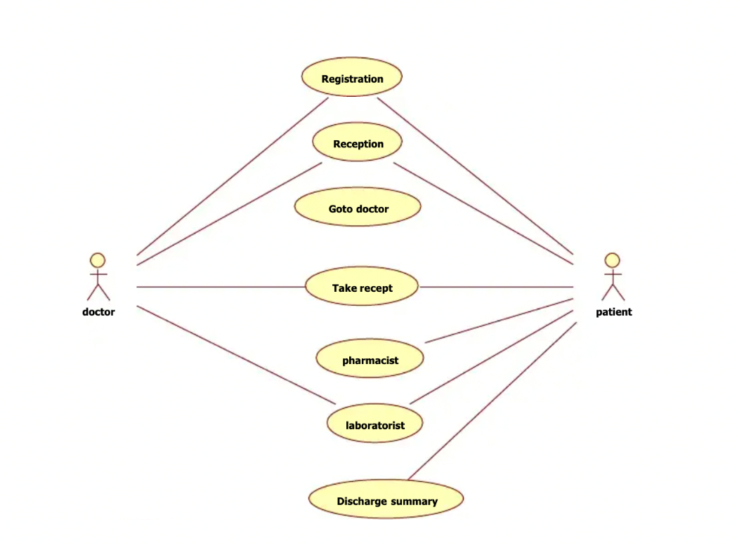

* + 1. **PATIENT**

**\*** REGISTRATION

DESCRIPTION - The new patient can register themselves and add their details like name, age, gender, blood group etc. The patient entry will be made in the hms database.

PRE -CONDITION – The patient must be a new patient, If necessary fields left by user then prompt user to fill the necessary fields.

MAIN FLOW OF EVENTS

* Patient selects sign up in login module.
* A registration form gets displayed.
* Patient fills the required details.

POST CONDITIONS - Patient record is added to hms database.

**\*** UPDATION

DESCRIPTION-The patient should be enabled to update his/her details and the changes should reflect in hms database.

PRE-CONDITION – The patient must be a registered patient. The patient cannot update details after treatment starts.

MAIN FLOW OF EVENTS

* Patient logs in to the system.
* Patient view his record.
* Patient selects update details.
* Now patient may change the necessary fields.
* Pop of update details.

POST CONDITION - The record of patient is updated in hms database.

**\*** APPOINTMENT

DESCRIPTION - It shows users a list of available doctors, timings, dates and enables patients to select the most suitable appointment date and doctor. The patient may also the cancel the appointment.

PRE-CONDITION - The patient must be a registered patient. Patient can fix only one appointment for a particular department.

MAIN FLOW OF EVENT

* Patient first logs in to system.
* View his/her record.
* Create a new appointment or cancel the appointment.

POST CONDITIONS - patient details are displayed and a new appointment is fix or an existing appointment is cancelled. The hms database is updated.

* + 1. **DOCTOR**

DESCRIPTION- The doctor view patient record/ update his details and add description of the treatment given to patient.

PRE-CONDITION – The doctor must be a registered doctor, System does not allow the doctor to modify the qualification, hospital managed details.

MAIN FLOW OF EVENTS

* Doctor logs in to the system.
* Doctor may select view patient.
* Patient record is displayed with treatment history.
* Doctor adds description of patient treatment.
* Doctor may select appointment details.
* Appointment Requests is displayed with schedule.
* Doctor confirms or cancel appointment.

POST CONDITION – The patient and doctor ‘s database is updated.

* + 1. **ADMIN**

DESCRIPTION - The admin add doctor, update doctor details and verify payment and generate Bill/Receipt for the same.

MAIN FLOW OF EVENTS

* Admin logs in the system.
* Admin may add doctor new doctor.
* Admin fills the doctor’s details.
* Admin view Doctor record.
* Admin enters the doctor id in the system.
* Doctor details are displayed, Admin can update details.
* Admin Verify the payment submitted by the Patient.
* Generate Bill/Receipt and confirmation message for the same.

POST CONDITION - The hms database is updated.

* 1. **User Characteristics**
     1. **ADMIN**

Admin has the full access to the system which means he is able to manage any activity with regard to the system. He is the highest privileged user who can access to the system.

Key functions

* Access patient record, doctor Record.
* Add new doctor entry in system database.
* Confirm Payment and Generate Bill.
* View Records. (Total no of patients treated, doctor added/remove, consultant fee).
  + 1. **PATIENT**

Patients can choose the best preferred appointments from the options provided and can also change the appointment schedule or cancel it. After appt. is confirmed by the respective doctor, they can pay their consultant fee to the doctor.

Key functions

* Make appointment
* Cancel appointment
* Update Details
  + 1. **DOCTOR**

Doctors can view the patient appointment list and provide the confirmation or make changes in the appointment list if required. Doctors have access to only records of those patients whom they are treating.

Key functions

* Confirmation of appointment
* Cancellation of appointment
* Modification of appointment list
* Add Prescription
  1. **Economic, Environmental, Health, manufacturability, Safety, Professional, Ethical, Social & Political Issues considered in design.**
     1. **Economic**

This study is carried out to check the economic impact will have on the system will have on the organization. The amount of fund that the company can pour into the research and development of the system is limited. The expenditures must be justified. Thus, the developed system as well within the budget and this was achieved because most of the technologies used are freely available. Only the customized products have to be purchased.

* + 1. **Technical**

This is concerned with specifying equipment and software that will successfully satisfy the user requirement; the technical needs of the system may vary considerably, but might include.

The facility to produce outputs in a given time

* Response time under conditions.
* Ability to process a certain volume of transaction at a particular seep.
* Facility to communicate data to distant location.
  + 1. **Safety**

If there is extensive damage to a wide portion of the database due to catastrophic failure, such as a disk crash, the recovery method restores a past copy of the database that was backed up to archival storage and reconstructs a more current state by reapplying or redoing the operations of committed transactions from the backed-up log, up to the time of failure. All the administrative and data entry operators have unique logins so system can understand who is login in to system right now no intruders allowed except system administrative nobody cannot change record and valuable data.

* + 1. **Legal**

A determination of any infringement, violation, or liability that could result from development of the system. Legal feasibility tells that the software used in the project should be original purchased from the legal authorities and they have the license to use it or the software are pirated.

* + 1. **Social**

Social feasibility is a determination of whether the project will be acceptable to the people or not. This determination typically examines the probability of the project accepted by the group directly affected by the proposed system change.

* 1. **Analysis and Feature finalization subject to constraints**

|  |  |  |  |
| --- | --- | --- | --- |
| **S. No.** | **MODULE**  **NAME** | **APPLICABLE**  **ROLES** | **DESCRIPTION** |
| 1. | LOGIN | PATIENT DOCTOR ADMIN | **PATIENT:** Can login using unique Id and Password after this system shall show his/her profile.  **DOCTOR:** Can login using unique Id and Password after this system shall show his/her profile.  **ADMIN:** Can login using unique Id and Password after this system shall show a profile with links to maintain the website. |
| 2. | REGISTRATION | PATIENT | **PATIENT:** Can Register by filling all the required details, after this the system will verify the details and check if already registered or not. |
| 3. | MAKE APPT. | PATIENT | **PATIENT:** Can Select doctor, date time and make an appointment request after this system shall show a confirmation for appointment request. |
| 4. | CANCL APPT. | PATIENT DOCTOR | **PATIENT:** Can Cancel appointment if want to by just one click after this system shall ask for re-schedule or refund of payment.  **DOCTOR:** Can Cancel appointment if want to by just one click after this system shall send a message to the patient. |
| 5. | DOCTOR MODULE | ADMIN | **ADMIN:** Can add a new doctor by filling all the details after this system shall show a confirmation message.  Can Remove a doctor by just one click after this system shall show confirmation message. |
| 6. | PATIENT MODULE | PATIENT | **PATIENT:** Can view payment history or can search for a particular bill also after this system shall show a bill or history.  Can also See or search for a doctor by entering dept. name or doctor id if known after this system will check for the doctor if found shall show doctor’s profile.  Can also update details after this system shall ask for re-enter password and after verifying password shall update details. |
| 7. | ADD PRESCRIPTION | DOCTOR | **DOCTOR:** Enter Patient Id and after this all the treatment details and medicine, remark and advice for the patient after this system shall show a message for update. |

* 1. **Design Flow (at least 2 alternative designs to make the project), Best Design selection (supported with comparison and reason) and Implementation plan ((Flowchart /algorithm/ detailed block diagram).**

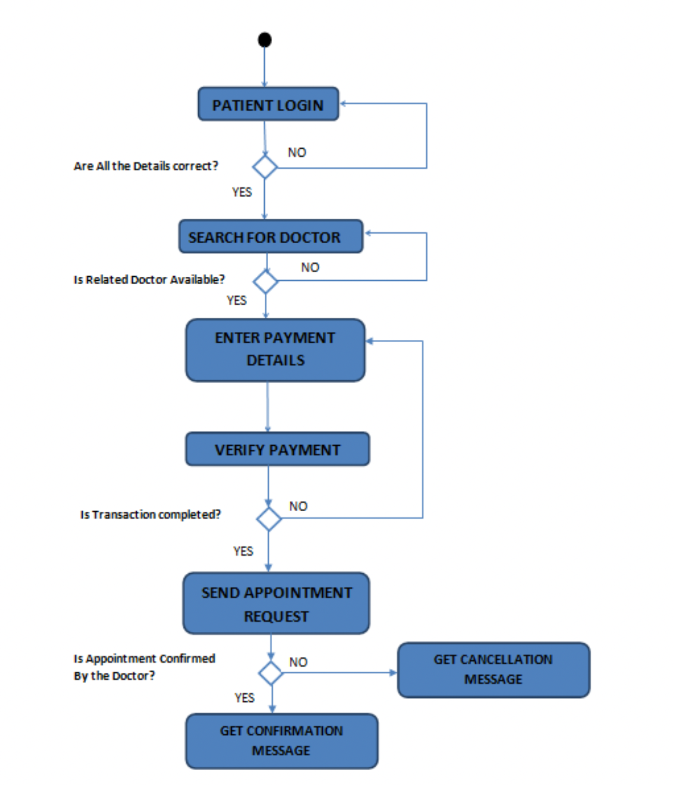

* + 1. **DATA DESIGN**
* **Patient**

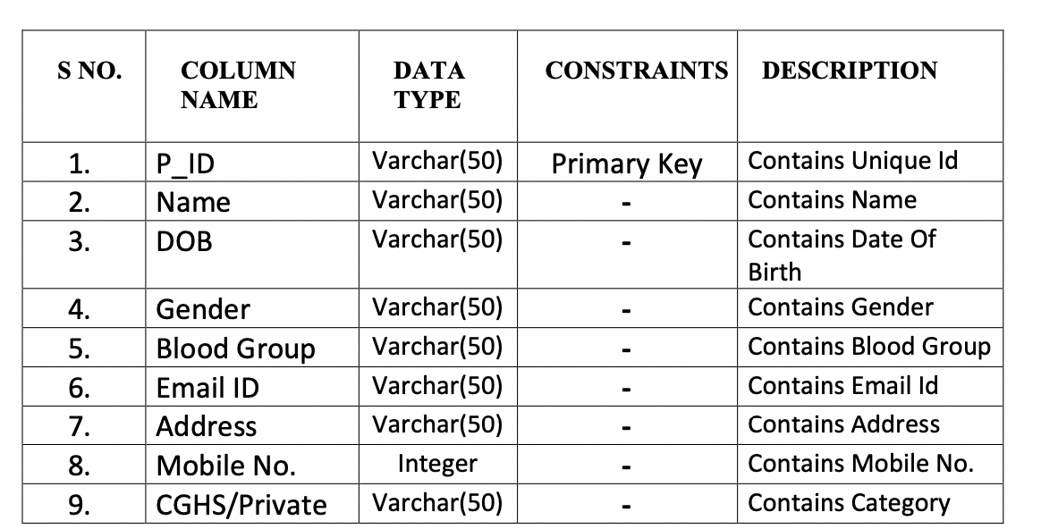

* **Appointment**

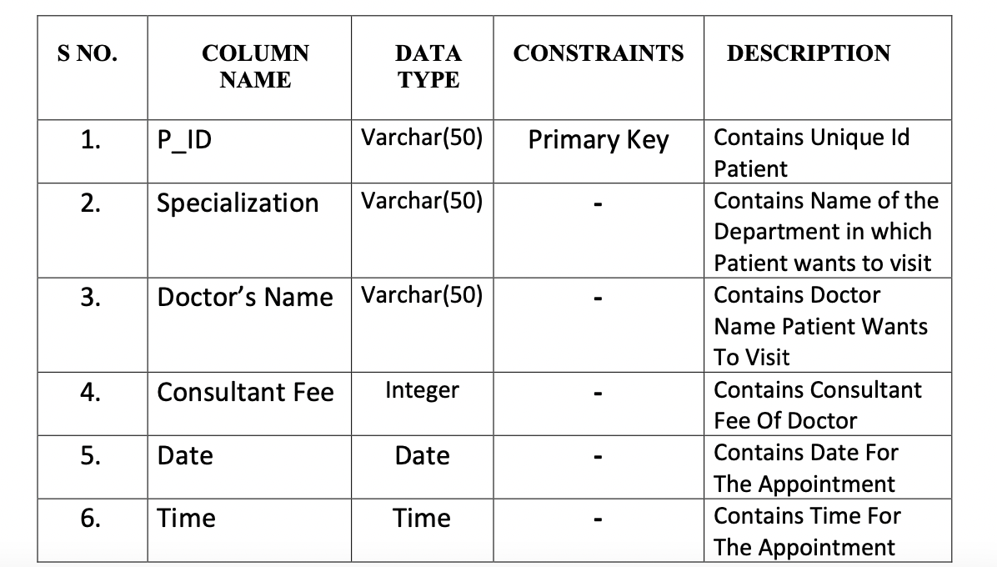

* **Doctor**

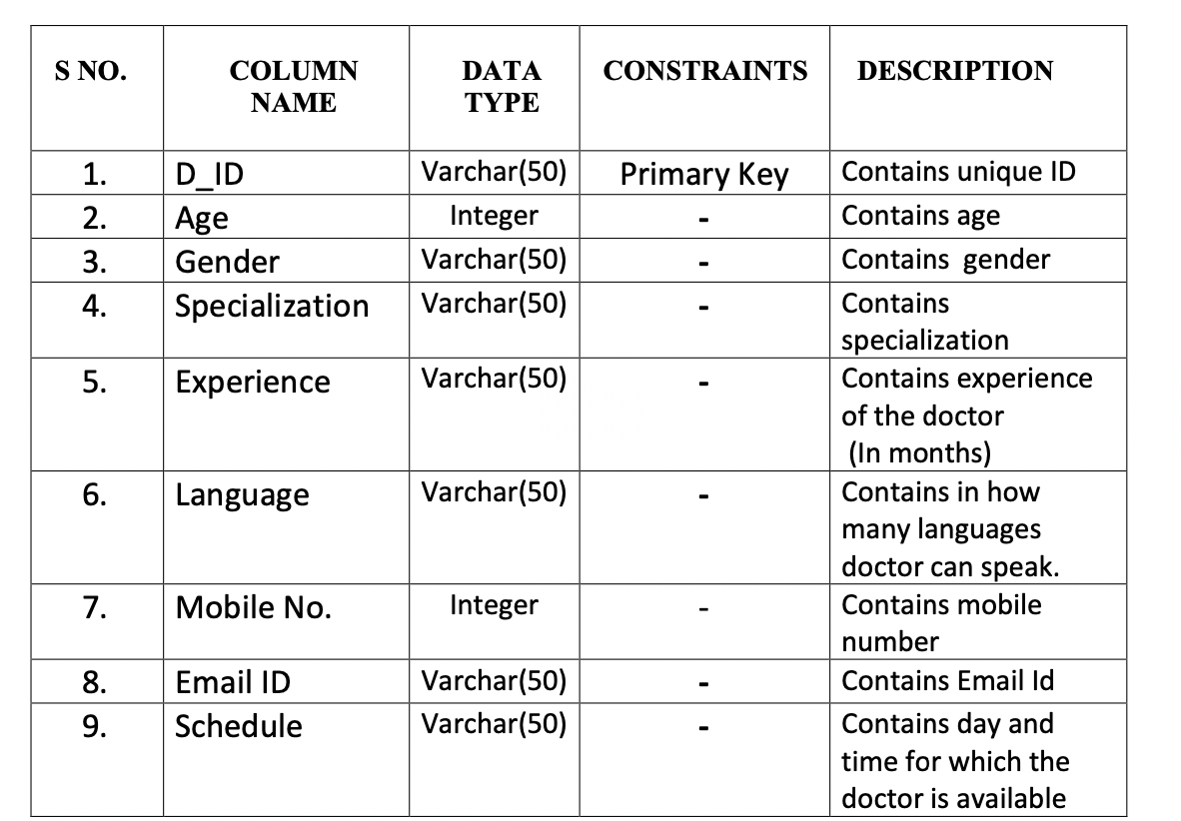

* **Prescription**

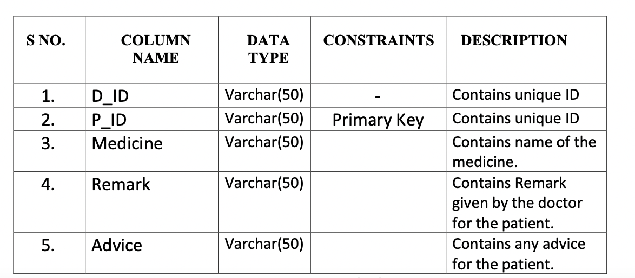

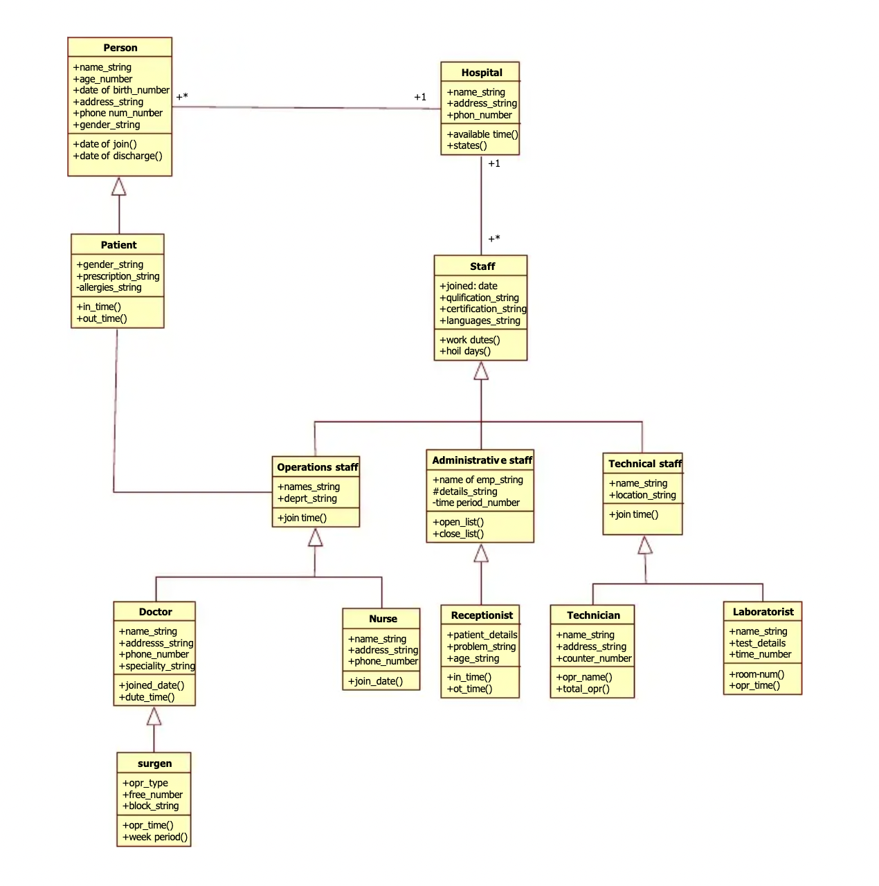

A category or group of things that has similar attributes and common behaviour. A Rectangle is the icon that represents the class it is divided into three areas. The upper most area contains the name, the middle; area contains the attributes and the lowest areas show the operations. Class diagrams provides the representation that developers work from. Class diagrams help on the analysis side, too.

CHAPTER 4

Result Analysis and Validation

1. **SOFTWARE SPECIFICATION**

Software Requirements deal with defining software resource requirements and pre-requisites that need to be installed on a computer to provide optimal functioning of an application. These requirements or pre-requisites are generally not included in the software installation package and need to be installed separately before the software is installed.

* 1. **HTML:**

HTML or Hypertext Markup Language is the standard markup language used to create web pages.

HTML is written in the form of HTML elements consisting of tags enclosed in angle brackets (like <html>). HTML tags most commonly come in pairs like <hl> and </hl>, although some tags represent empty elements and so are unpaired, for example <mg>. The first tag in a pair is the start tag, and the second tag is the end tag (they are also called opening tags and closing tags). Though not always necessary, it is best practice to append a slash to tags which are not paired with a closing tag.

The purpose of a web browser is to read HTML documents and compose them into visible or audible web pages. The browser does not display the HTML tags, but uses the tags to interpret the content of the page. HTML describes the structure of a website semantically along with cues for presentation, making it a markup language rather than a programming language.

HTML elements form the building blocks of all websites. HTML allows images and objects to be embedded and can be used to create interactive forms. It provides a means to create structured documents by denoting structural semantics for text such as headings, paragraphs, lists, links, quotes and other items. It can embed scripts written in languages such as JavaScript which affect the behaviour of HTML web pages.

* + 1. **CASCADING STYLE SHEETS (CSS):**

It is a style sheet language used for describing the look and formatting of a document written in a markup language. While most often used to style web pages and interfaces written in HTML and XHTML, the language can be applied to any kind of XML document, including plain XML, SVG and XUL. CSS is a cornerstone specification of the web and almost all web pages use CSS style sheets to describe their presentation.

CSS is designed primarily to enable the separation of document content from document presentation, including elements such as the layout, colors, and fonts. This separation can improve content accessibility, provide more flexibility and control in the specification of presentation characteristics, enable multiple pages to share formatting, and reduce complexity and repetition in the structural content.

CSS can also allow the same markup page to be presented in different styles for different rendering methods, such as on-screen, in print, by voice (when read out by a speech-based browser or screen reader) and on Braille-based, tactile devices. It can also be used to allow the web page to display differently depending on the screen size or device on which it is being viewed. While the author of a document typically links that document to a CSS file, readers can use a different style sheet, perhaps one on their own computer, to override the one the author has specified. However, if the author or the reader did not link the document to a specific style sheet the default style of the browser will be applied.

* + 1. **MySQL:**

MySQL is developed, distributed, and supported by Oracle Corporation. MySQL is a database system used on the web it runs on a server. MySQL is ideal for both small and large applications. It is very fast, reliable, and easy to use. It supports standard SQL. MySQL can be compiled on a number of platforms.

The data in MySQL is stored in tables. A table is a collection of related data, and it consists of columns and rows. Databases are useful when storing information categorically.

**FEATURES OF MySQL:**

**Internals and portability:**

1. Written in C and C++.
2. Tested with a broad range of different compilers.
3. Works on many different platforms.
4. Tested with Purify (a commercial memory leakage detector) as well as with Val grind, a GPL tool.
5. Uses multi-layered server design with independent modules.

**Security:**

* A privilege and password system that is very flexible and secure, and that enables host-based verification.
* Password security by encryption of all password traffic when you connect to a server.

**Scalability and Limits:**

* Support for large databases. We use MySQL Server with databases that contain 50 million records. We also know of users who use MySQL Server with 200,000 tables and about 5,000,000,000 rows.
* Support for up to 64 indexes per table (32 before MySQL 4.1.2). Each index may consist of 1 to 16 columns or parts of columns. The maximum index width is 767 bytes for **InnoDB** tables, or 1000 for **MyISAM**; before MySQL 4.1.2, the limit is 500 bytes. An index may use a prefix of a column for **CHAR**, **VARCHAR**, **BLOB**, or **TEXT** column types.
  1. **CONNECTIVITY:**

Clients can connect to MySQL Server using several protocols:

* Clients can connect using TCP/IP sockets on any platform.
* On Windows systems in the NT family (NT, 2000, XP, 2003, or Vista), clients can connect using named pipes if the server is started with the --enable-named pipe option. In MySQL 4.1 and higher, Windows servers also support shared-memory connections if started with the --shared-memory option. Clients can connect through shared memory by using the --protocol=memory option.
* On UNIX systems, clients can connect using Unix domain socket files.
  + 1. **LOCALIZATION:**
* The server can provide error messages to clients in many languages.
* All data is saved in the chosen character set.
  + 1. **CLIENTS AND TOOLS:**
* MySQL includes several client and utility programs. These include both command-line programs such as mysqldump and mysqladmin, and graphical programs such as MySOL Workbench.
* MySQL Server has built-in support for SQL statements to check, optimize, and repair tables. These statements are available from the command line through the mysqlcheck client. MySQL also includes myisamchk, a very fast command-line utility for performing these operations on MyISAM tables.
* MySQL programs can be invoked with the -help or -? option to obtain online assistance.

**WHY TO USE MySQL:**

* Leading open-source RDBMS
* Ease of use - No frills
* Fast
* Robust
* Security
* Multiple OS support
* Free
* Technical support
* Support large database- up to 50 million rows, file size limits up to 8 million TB
  1. **HARDWARE REQUIREMENTS:**

The most common set of requirements defined by any operating system or software application is the physical computer resources, also known as hardware. A hardware requirements list is often accompanied by a hardware compatibility list (HCL), especially in case of operating systems. An HCL lists tested, compatibility and sometimes incompatible hardware devices for a particular operating system or application. The following sub-sections discuss the various aspects of hardware requirements.

* + 1. **HARDWARE REQUIREMENTS FOR PRESENT PROJECT:**

PROCESSOR : Intel dual Core, i3

RAM : 1 GB

HARD DISK : 80 GB

* 1. **SCREENSHOTS**

